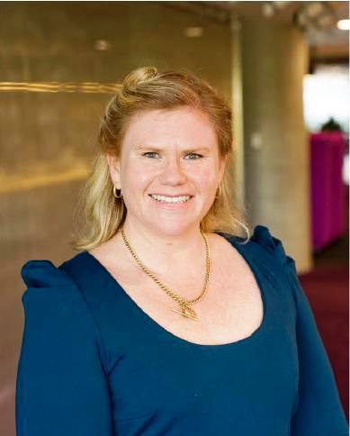
The Psychology of Change
By Kate Morris, PMI Sydney Special Projects Director
I was lucky enough to hear a colleague discuss his ideas on how project managers can look to some basic psychology theories to assist in delivering projects and helping stakeholders and customers not just accept the change, but enjoy the process!
In our day to day activities as project professionals we are always faced with implementing change. Sometimes, the change is easy and easily accepted. Most of the time for me at least, the change can be hard, with stakeholders and customers pushing back. So as catalysts for change, what techniques are available to get more acceptance and a smoother project implementation?
One of the theories we discussed was the The Self Determination Theory (STD) is centrally concerned with motivation. How easy is it to convince someone to do what you want if they don’t associate the change with themselves? Think on a project; how easy is it to get buy-in from stakeholders when the change you will make is very large to their day to day activities. Perhaps the change is actually to make their life easier, but if they have no connection with the change you will have a harder time working with them and potentially they could hamper your efforts and spread negativity to other stakeholders on your project.
Looking at STD – there are 4 distinct stages pictured below
External – where the idea is seen as someone else’s e.g. someone else tells you to give up smoking.
Introjected – Where you contemplate the idea e.g. you look at the idea of giving up smoking.
Identified – You identify with the idea e.g. you think you should give up smoking.
Internal – You take on the idea and are motivated to see it through e.g. you give up smoking.
So how do you get people to be motivated to take on your idea ?
Think about this the next time you engage your stakeholders. Are they fully on board with your change or do you need to take the time to help them take ownership of the change and become your champion?
Some tips I regularly use with my stakeholders;
Communication – biggest game changer!!! Get out there and campaign your change. Listen to what people are talking about and aim for 1:1 time with those that need to be taken on the journey
WIIFM (What's In It For Me) - a great way of getting stakeholders to move from external to introjected. You know then where to place more emphasis on explaining the change and the benefits they would receive in being on board

Let them have time to contemplate the change – give stakeholders the opportunity to reflect on what you are proposing before implementing the change. A chance to think about things and discussing with their peers could get them onside with what you are proposing
Support your champion – when you have a supporter of your change, make sure they get the support required to help you campaign to stakeholders that are still not on board. It’s amazing to see how the tide turns when support snowballs from self-motivation

